Types of Conjunctions
# Source: AI Source: Provided by: [Data Path: Persons Table -> ID Column: 1, Name_En Column: Motasem Essam] -> From: [Chatgpt (GPT-4-turbo)] on [7/28/2025]
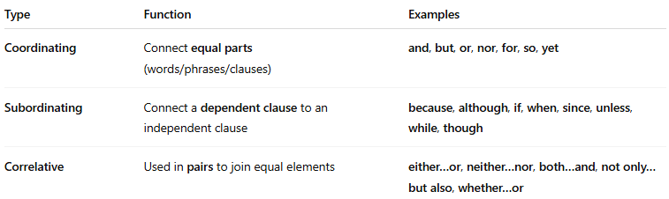

Type | Function | Examples
Coordinating | Connect equal parts (words/phrases/clauses) | and, but, or, nor, for, so, yet
Subordinating | Connect a dependent clause to an independent clause | because, although, if, when, since, unless, while, though
Correlative | Used in pairs to join equal elements | either…or, neither…nor, both…and, not only…but also, whether…or

